Section 1: Metadata
to be filled by the student

1.1. Project Information to be filled by the student
Title: Inventory Management System
Section: L1 | Instructor: Maria Samad

1.2. Student(s) Information
Name: Ali Hani Jiwani | ID: AJ10903
Section: L1 | Batch: 2029

Name: Sojhal Mehtab | ID: SM11088
Section: L1 | Batch: 2029

Name: Muhammad Hasan Raza | ID: MR11501
Section: L1 | Batch: 2029

Submission guideline: Save your project proposal as a pdf file and rename as Project Proposal_L1_ProposedTitle where L1 is to be replaced with your section

Section 2: The Project
to be filled by the student

2.1. Project Description: Please provide a brief introduction of the project including its scope.
Introduction
We are building an Inventory Management System, a desktop application that runs on an SQLite database. It keeps a retail store's stock records accurate from the day products arrive in inventory until they are sold, and it follows anything customers bring back. Most shops do all of this on paper. We fold four of those paper jobs into one application: recording sales, keeping count of every product on the shelves, reordering from suppliers before stock runs out (using thresholds the admin sets), and handling returns under the store's return policy.
Practical Relevance
Plenty of small and medium stores, from general stores and supermarkets to pharmacies, still keep their stock counts in registers. Someone updates the register later, away from the sales counter where the sale happened. Counting by hand makes it worse:
• Products get oversold because nobody reordered in time
• Hand counts at every step, so the stock numbers drift away from what is on the shelves
• Returns decided case by case
• No record of who made each entry
• Sales and profit figures that nobody can pull up without going through the registers by hand
Proposed Solution and Functionality:
Everything runs through one database, so the counter, the stock records, supplier orders and returns all work from the same numbers:
• Checkout confirms the stock is there before anything is sold. The sold quantity then comes off the count, and a product that drops to its reorder level gets a restock order automatically.
• A refund only goes through while the item is inside its category's return window and the customer is returning at most what they bought. Returned units go straight back into stock.
• Each sale and refund is stamped with the employee who handled it.
• Managers choose a period, say last month, and see units sold, earnings, profit and the top seller.

.
.
Scope
In scope:
• Employee login, with each role limited to its own screens.
• Checkout at the counter with multi-item receipts and a stock check on every line.
• Adding products, updating stock and recording deliveries.
• Restock orders raised automatically when stock runs low, each with a status that staff can track.
• Return windows per product category. Full and partial refunds, with the returned items put back into stock.
• Managing employee accounts.
• Sales and stock statistics for whatever period the user picks.
2.2 Functional Requirements
This section describes each function/feature provided by your system. These functions are logically grouped into modules based on their purposes. The users in your system must be categorized such as client, customer or administrator etc. These users will be accessing the database with the level of access that they are authorized with.
User Roles and Access Levels
Role | User role | Access
Administrator (Store Manager) | Administrator | Full control. Runs employee accounts and return policies and can open every screen and report.
Stock Manager | Power user | Looks after the product catalogue, receives deliveries, follows restock orders and checks sales statistics.
Cashier | General user | Rings up sales and handles customer refunds. Can see their own sales history.

Modules and Functions
Module 1: Login and Access (all users)
• Function 1: Employee login (Minor Transaction 1): An employee types their Employee ID and password into the Login screen. The system finds that employee, hashes the password and compares it with the stored hash, then checks that the account has not been deactivated. If either detail is wrong, the only message shown is "Invalid ID or password".
• Function 2: Role-based access: Once logged in, employees see only the screens their role allows.
• Function 3: Employee tracking: Whoever is logged in has their ID saved with each sale and refund, and their name appears as the cashier on the Point of Sale screen.
Module 2: Point of Sale (Cashier, Administrator)
• Function 1: Add item to cart: The cashier scans a barcode or types it in, sets the quantity and clicks Add. After a barcode lookup (Minor Transaction 2), a new cart row appears with the product name, quantity and price, for example 5 Apples for 100.
– Function 1a: Stock check: An unknown barcode, a quantity of zero or a quantity above the stock on hand stops the item from going in. A message tells the cashier which problem it was.
– Function 1b: Repeated items: Scanning a barcode already in the cart raises that row's quantity, and the combined total is checked against the stock on hand again.
• Function 2: Running total: The side panel keeps a running total next to the cashier's name.
• Function 3: Checkout (Master Transaction 1): Checkout saves the whole cart as one sale with a new Sale ID and gives the receipt its own customer ID. Sold quantities come off the stock count, every product that falls to its reorder level gets a restock order, and if any of these steps fails the whole sale is rolled back.
• Function 4: Sales history (Minor Transaction 4): The History table lists the logged-in cashier's own sales, newest first, with the Sale ID, total price, time, date and cashier for each one. It updates after every checkout.
Module 3: Inventory and Stock Intake (Stock Manager, Administrator)
• Function 1: Barcode auto-fill (Minor Transaction 2): Typing a barcode on the Inventory screen triggers a lookup. For a product the store already carries, the name, category, prices and current quantity fill in by themselves and the name field locks. An unknown barcode leaves the form blank for a new product.
• Function 2: Add a new product or receive stock (Master Transaction 3): Clicking Update/Add on a new barcode creates a product with its name, category, purchase price, cost price, quantity and reorder level. An existing barcode gets the new quantity added to its stock, plus updated prices. Purchase price means the customer's price, and cost price is what the store paid its supplier. Open restock orders for that product close as Fulfilled.
– Function 2a: Input validation: The form refuses to save without a barcode and a product name. Prices can be zero or higher, the quantity has to be at least 1, and the category needs a return policy already set up. A purchase price below the cost price triggers a warning.
• Function 3: Stock table: Under the form, a table lists every product's barcode, name, purchase price, cost price and quantity, and it refreshes after each update. Anything at or below its reorder level shows in a different colour.
Module 4: Automatic Restocking (Stock Manager, Administrator)
• Function 1: Automatic restock orders: When a sale drops a product to or below its reorder level, the system places a restock order using the reorder settings the admin has chosen.
Module 5: Returns and Refunds (Cashier, Administrator)
• Function 1: Fetch receipt: The cashier types in the Sale ID from the customer's receipt and clicks Fetch Order. Every item from that sale appears with its barcode, product name, sold quantity and unit price, minus anything already refunded. The Information panel beside it gives the sale date, the number of days since the sale, the policy status and the cashier who rang it up.
• Function 2: Return eligibility check: Each item is checked against its category's return window, and anything past that window is marked not eligible with its checkbox locked. The policy status says how many can come back: all, some or none.
• Function 3: Choose items to refund: The cashier ticks whatever the customer is bringing back and enters a quantity for each row, up to the amount still refundable. Select All ticks every eligible item and Deselect All clears them. Each row's refund (return quantity × unit price) updates as the selection changes, along with the total items and total refund in the Summary panel. Returning 5 of 10 Apples at 10 each, for example, shows a refund of 50.
• Function 4: Process refund (Master Transaction 2): Refund Selected Items pays back the ticked rows at the quantities typed in, and the Refund All Items button takes back every eligible unit not yet refunded. Either way, the refund is saved under the employee who processed it and the stock goes back up, unless an item fails validation, in which case nothing is refunded at all.
Module 6: Return Policy Configuration (Administrator)
• Function 1: Set return window (Minor Transaction 3): The Administrator picks a category, enters how many days customers have to return its products and clicks Update Policy. A store could give perishables 1 day, electronics 14 and general goods 30. Setting 0 makes a category non-returnable. Refund checks use the new number straight away.
• Function 2: Read-only view for other roles: Cashiers can see the current return window on the Support and Return screen, but for them the Update Policy button stays greyed out.
Module 7: Employee Management (Administrator) [Screen to be made]
• Function 1: Create employee account: The Administrator fills in the new employee's name, a starting password and a role, which is Administrator, Stock Manager or Cashier. An Employee ID is assigned automatically. Only a hash of the password is stored.
• Function 2: Update or deactivate account: The Administrator can change a role or reset a password at any time. Staff who leave get deactivated, so they can no longer log in, and their name stays attached to every sale and refund they handled.
Module 8: Sales and Inventory Statistics (Stock Manager, Administrator)
• Function 1: Period statistics (Minor Transaction 5): From the drop-down in the Inventory Stats panel, the user chooses Today, Last 7 Days, Last Month or All Time. The panel then reports units sold, total earnings, profit (earnings minus the cost price of what was sold) and whichever product sold the most units in that period.
Tables (May Change)
Entity | Description | Main attributes
Employees | Staff logins and roles | employee_id (PK), name, role, password_hash, is_active
Policy | Return window in days, set per product category, that refund checks compare against | category (PK), return_window_days
Inventory | Products and stock levels | barcode (PK), product_name, category, purchase_price, cost_price, quantity, reorder_level, reorder_quantity
Sales | One row per product sold, so a single receipt can take up several rows with the same sale_id | sale_id + barcode (composite PK), barcode, quantity, unit_price, employee_id, sale_datetime
Customers | The customer ID generated for each receipt at checkout, linked to its sale_id | customer_id (PK), sale_id, created_at
Orders | Restock orders for suppliers | order_id (PK), barcode, quantity_ordered, status, order_date, fulfilled_date
Refunds | Every item a customer returns, with the quantity and the amount paid back | refund_id (PK), sale_id + barcode, quantity_refunded, refund_amount, refund_datetime, processed_by

Transaction Summary
Master transactions touch three or more entities each. They run as single database transactions, so a failure at any step rolls back every change.
Master Transaction 1:
Screen | Point of Sale, when the cashier clicks Checkout
Entities | Sales, Customers, Inventory, Orders (reads Employees for the cashier)

Master Transaction 2:
Screen | Support and Return, after the cashier clicks Refund Selected Items or Refund All Items
Entities | Sales, Refunds, Inventory, Policy, Customers, Employees

Master Transaction 3:
Screen | Inventory screen (the stock manager clicks Update/Add)
Entities | Inventory, Policy, Orders

Minor transactions.
Minor transaction | Entities | Screen
Employee login | Employees | Login
Barcode lookup | Inventory | Point of Sale (Add) and Inventory
Update return window | Policy | Support and Return (Policy Configuration)
Cashier sales history | Sales, Employees | Point of Sale (History)
Period sales statistics | Sales, Inventory | Inventory (Inventory Stats)

2.3. Planned Schedule: Kindly list the start/end dates and the timeline for the achievement of any intermediate milestones and the expected contribution to be made by the participant(s).
Timeline (To be Consulted with Instructor)
Week | Milestone
Week 4 | Proposal submission
Weeks 4–7 | ERD design
Week 8 | Interim ERD
Weeks 9–12 | Implementation
Week 13 | Interim demo
Weeks 14–15 | Testing and final submission

2.4. Technology Stack: If you are utilizing any language or database besides PyQt and SQL Server, please complete this section; otherwise, leave it blank. Specify the programming language and database management system intended for constructing this application, as well as the application type (Desktop, Web, or Mobile).

Main Programming Language: Python, with PyQt6 for the interface
Database Management System: SQLite
Application Type: Desktop
2.5. Screens: Provide images of all application screens, showcasing clear input and corresponding outputs. Ensure each image includes a concise caption explaining user action and expected/observed output. You can create these screens using Qt Designer.
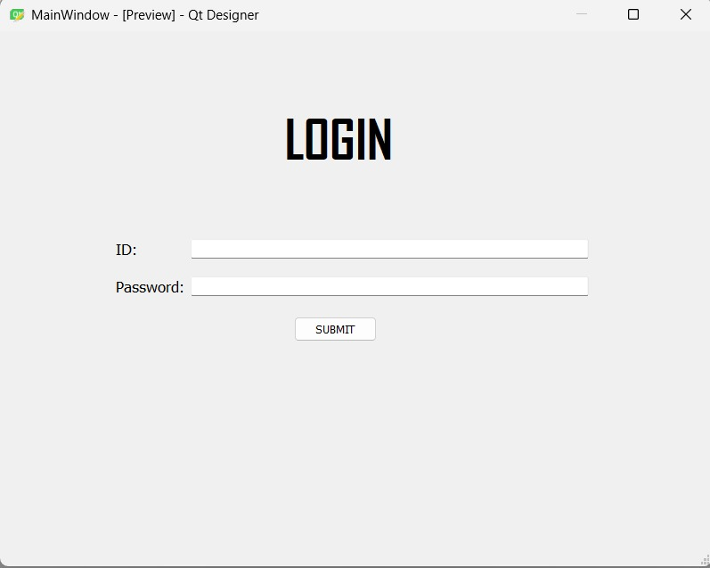
User action: The employee types in their Employee ID and password, then presses SUBMIT.
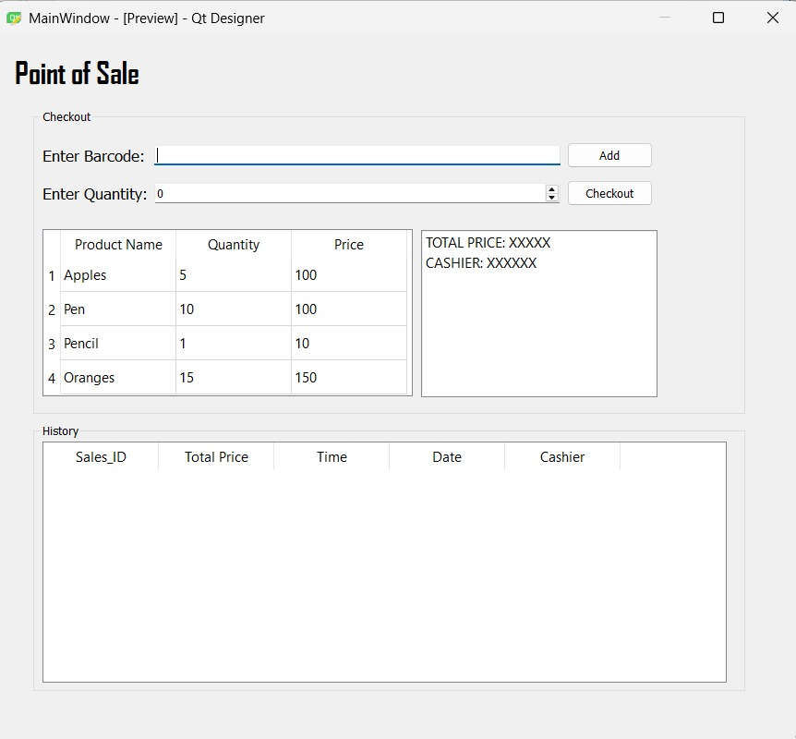
User action: For each product, the cashier scans or types the barcode, sets a quantity and clicks Add. Checkout completes the sale.
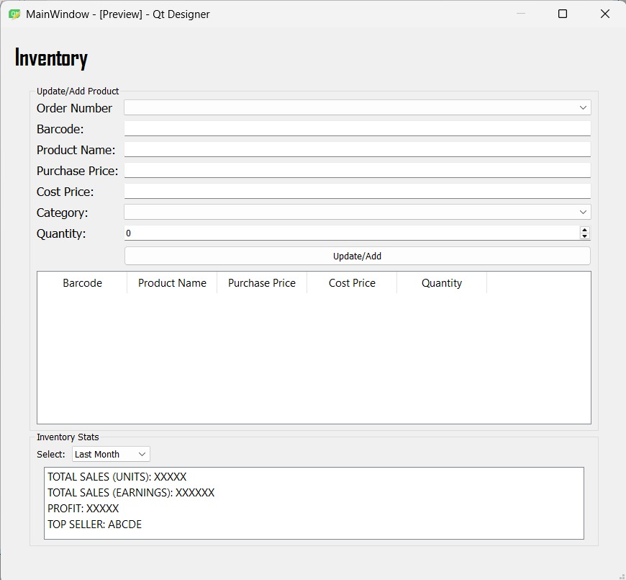
User action: The stock manager enters a barcode. An existing product's details fill in on their own, and for a new one the stock manager types the name, purchase price and cost price. After entering the quantity received they click Update/Add, and under Inventory Stats they can pick a period such as Last Month.
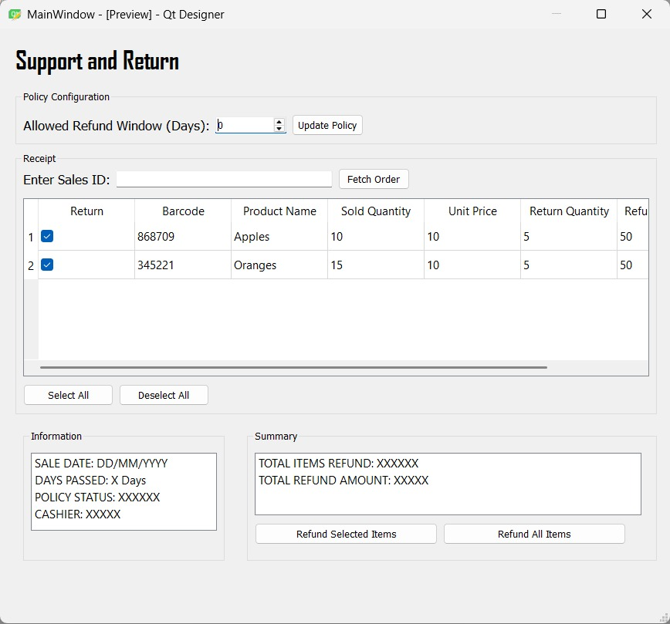
User action: The cashier enters the Sale ID from the receipt and clicks Fetch Order. They tick the items coming back (or press Select All), type a return quantity for each and finish with Refund Selected Items or Refund All Items. An Administrator can also change the refund window under Policy Configuration and save it with Update Policy.

